SIMATS ENGINEERING
ASSESSMENT TOOL 2

COURSE NAME: Artificial Intelligence COURSE CODE: CSA17

COURSE OUTCOME COVERED

CO1: Apply AI basics such as intelligent agents and uninformed search methods to solve problems effectively.( BL3)

Assessment Tool Weightage: 50%

QUESTIONS: 3 Duration : 1 Hour
Total Marks:30

Annexure A

Constraint-Based Problem Solving

Code of Conduct:

I ____________________ (Name / Reg No) certify that this submission is my original work and that I have adhered to the guidelines specified for this assessment.
I understand that any violation of academic integrity rules will result in disciplinary action.

Signature of the student:

Annexure A

Constraint-Based Problem Solving

- A hospital needs to assign 3 doctors (D1, D2, D3) to 3 shifts (Morning, Afternoon, Night) such that:
Constraints:
- D1 cannot work Night shift
- D2 must work before D3 (Morning < Afternoon < Night)
- Only one doctor per shift
- D3 cannot work Morning
- All doctors must be assigned exactly one shift
Apply Backtracking Search to find a valid assignment with all intermediate steps and constraint checks. State the final valid schedule
- A robot operates in a grid environment (5×5). It must move from Start (S) to Goal (G). Obstacles block certain paths.

Constraints:
- Movement allowed: Up, Down, Left, Right
- Cost of each move = 1
- Cannot pass through obstacles
- Use Manhattan Distance heuristic
Using above constraints and BFS Search Algorithm Show step-by-step node expansion and priority queue updates and determine the optimal path and cost.

- An autonomous rescue robot is deployed in a disaster-affected building to locate and rescue survivors. The robot operates in a partially observable environment where some paths are blocked, and it must make decisions with limited information.
The building is represented as a grid of rooms. The robot starts at position S and must reach a survivor located at G.

Constraints:
- The robot can move up, down, left, right
- Some cells are blocked (obstacles) and cannot be traversed
- The robot has limited sensing capability (can only observe adjacent cells)
- Each movement has a cost of 1, but entering risky zones has an additional cost of 2
- The robot must minimize total cost while ensuring safe navigation
- The robot must update its knowledge dynamically (online search scenario)

Tasks:
a) Analyze all the given constraints and explain how they affect the robot’s decision-making process.
b) Develop a solution approach using an appropriate search strategy (e.g., Uniform Cost Search / Online Search Agent). Clearly explain the steps involved.
c) Demonstrate how the robot applies AI concepts such as:
- Intelligent agents
- Rationality
- Environment type
d) Justify why your chosen approach is the most suitable for solving this problem under the given constraints.

RUBRICS FOR CALCULATION:

Criteria | Weightage | Level 4 (Exemplary) | Level 3 (Proficient) | Level 2 (Developing) | Level 1 (Beginning)
Problem Understanding | 25% | Clearly defines the problem and identifies all relevant constraints accurately | Identifies most constraints with minor gaps | Partial understanding; misses key constraints | Fails to identify constraints correctly
Constraint Analysis | 25% | Analyzes constraints effectively and prioritizes them logically | Provides reasonable analysis with some prioritization | Limited analysis; weak prioritization | No meaningful analysis or prioritization
Solution Development | 25% | Develops optimal and feasible solutions satisfying all constraints | Develops workable solutions with minor limitations | Solutions partially satisfy constraints | Solutions do not meet constraints
Application of Concepts | 15% | Effectively applies appropriate concepts, methods, or tools | Applies concepts with minor errors | Limited application; requires guidance | Unable to apply relevant concepts
Justification | 10% | Provides strong justification for decisions with logical reasoning | Provides justification with some clarity | Weak or unclear justification | No justification provided

CSA1718 – Artificial Intelligence

1.
Aim
To develop a simple Python program using the Backtracking Search Algorithm to assign three doctors to three hospital shifts while satisfying all the given constraints.

Objectives
1. To understand the concept of a Constraint Satisfaction Problem (CSP).
2. To learn how the Backtracking Search Algorithm works.
3. To assign one shift to each doctor.
4. To ensure that only one doctor is assigned to each shift.
5. To check all constraints before accepting an assignment.
6. To display the final valid doctor schedule.

Problem statement

A hospital needs to assign three doctors, D1, D2 and D3, to three shifts:
- Morning
- Afternoon
- Night
The following constraints must be satisfied:
- D1 cannot work the Night shift.
- D2 must work before D3.
The order of shifts is:
[ Morning < Afternoon < Night ]
- Only one doctor can work in each shift.
- D3 cannot work the Morning shift.
- Every doctor must be assigned exactly one shift.
The task is to use Backtracking Search to find a valid schedule.

Program :
doctors = ["D1", "D2", "D3"]
shifts = ["Morning", "Afternoon", "Night"]

assignment = {}
def valid(doctor, shift):
# D1 cannot work Night
if doctor == "D1" and shift == "Night":
return False

# D3 cannot work Morning
if doctor == "D3" and shift == "Morning":
return False
# Only one doctor per shift
if shift in assignment.values():
return False

# D2 must work before D3
if doctor == "D3" and "D2" in assignment:
order = {"Morning": 1, "Afternoon": 2, "Night": 3}
if order[assignment["D2"]] >= order[shift]:
return False
return True
def backtrack(index):
# If all doctors are assigned
if index == 3:
return True
doctor = doctors[index]
for shift in shifts:
print("Trying", doctor, "=", shift)
if valid(doctor, shift):
assignment[doctor] = shift
print("Accepted")
if backtrack(index + 1):
return True
del assignment[doctor]
print("Backtracking")
return False
backtrack(0)
print("\nFinal Schedule")
for doctor in doctors:
print(doctor, "=", assignment[doctor])
Output :
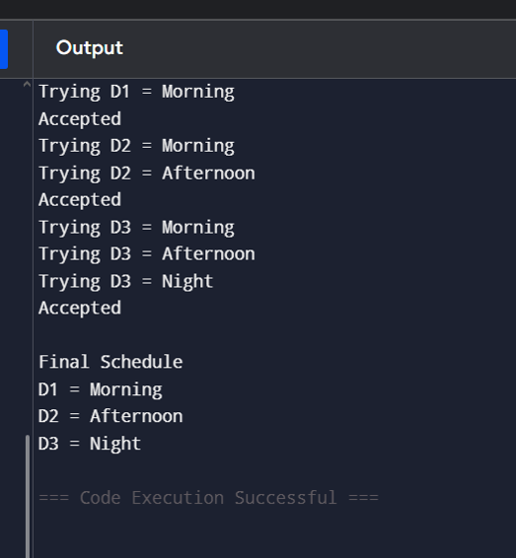

2.

Aim
To implement the A* Search Algorithm for finding the shortest path of a robot from the start position to the goal position in a 5×5 grid containing obstacles.

Objectives
- To represent a robot environment using a 5×5 grid.
- To allow the robot to move Up, Down, Left and Right.
- To prevent the robot from moving through obstacles.
- To use Manhattan Distance as the heuristic.
- To display the step-by-step node expansion.
- To find the optimal path from the start to the goal.
- To calculate the total path cost.

Problem Statement
A robot is placed in a 5 × 5 grid environment. The robot starts from the Start (S) position and must reach the Goal (G) position. Some cells in the grid contain obstacles (#), which the robot cannot cross.
The robot can move only in four directions:
- Up
- Down
- Left
- Right
Each movement has a cost of 1. The objective is to find the shortest path from the Start to the Goal while avoiding obstacles. The A* Search Algorithm is used with the Manhattan Distance heuristic to determine the optimal path and its total cost.
Program:
import heapq

# Grid
grid = [
['S', '.', '.', '.', '.'],
['.', '#', '#', '.', '.'],
['.', '.', '#', '.', '.'],
['.', '#', '.', '.', '.'],
['.', '.', '.', '.', 'G']
]

start = (0, 0)
goal = (4, 4)

# Up, Down, Left, Right
moves = [(-1,0), (1,0), (0,-1), (0,1)]

# Manhattan Distance
def heuristic(a, b):
return abs(a[0]-b[0]) + abs(a[1]-b[1])

# A* Search
def astar():
queue = []
heapq.heappush(queue, (0, start, [start]))
visited = set()

while queue:
cost, current, path = heapq.heappop(queue)

if current == goal:
return path

if current in visited:
continue

visited.add(current)

for move in moves:
x = current[0] + move[0]
y = current[1] + move[1]

if 0 <= x < 5 and 0 <= y < 5:
if grid[x][y] != '#' and (x, y) not in visited:
new_cost = len(path) + heuristic((x, y), goal)
heapq.heappush(queue, (new_cost, (x, y), path + [(x, y)]))

return None
# Run A*
path = astar()

print("Optimal Path:")
for p in path:
print(p)
print("Total Cost =", len(path)-1)
Output :
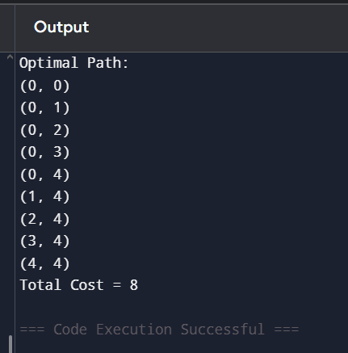
3.

Aim
To develop a simple Python program using Uniform Cost Search to help an autonomous rescue robot find a minimum-cost path from the start position to the survivor while avoiding obstacles and reducing movement through risky zones.

Objectives
- To represent the disaster-affected building as a grid.
- To allow the robot to move Up, Down, Left and Right.
- To prevent the robot from crossing blocked cells.
- To assign a cost of 1 for normal movement.
- To assign a cost of 3 for entering a risky cell.
- To find the path with the minimum total cost.
- To display the optimal path and total cost.

Problem Statement
An autonomous rescue robot operates inside a disaster-affected building represented as a grid.
The robot starts at position S and must reach a survivor located at position G.
The robot can move only in four directions:
- Up
- Down
- Left
- Right
Some cells are blocked by obstacles and cannot be entered.
A normal movement has a cost of 1. Entering a risky zone has an additional cost of 2. Therefore, the total cost of entering a risky cell is 3.
The robot must avoid obstacles and find a safe path with the minimum total cost. Uniform Cost Search is used because it always expands the path with the lowest accumulated cost.
program :

Corrected Simple Python Code
import heapq

grid = [
['S', '.', 'R', '.', '.'],
['.', '#', '#', 'R', '.'],
['.', '.', '.', '.', '.'],
['#', 'R', '#', '.', '.'],
['.', '.', '.', '.', 'G']
]

start = (0, 0)
goal = (4, 4)

# Up, Down, Left, Right
moves = [(-1, 0), (1, 0), (0, -1), (0, 1)]

def uniform_cost_search():

# Queue stores: cost, position, path
queue = [(0, start, [start])]

visited = set()

while queue:

cost, current, path = heapq.heappop(queue)

if current == goal:
return path, cost

if current in visited:
continue

visited.add(current)

for move in moves:

row = current[0] + move[0]
column = current[1] + move[1]

# Check grid boundary
if 0 <= row < len(grid) and 0 <= column < len(grid[0]):

# Check obstacle
if grid[row][column] != '#':

next_position = (row, column)

if next_position not in visited:

# Normal movement cost
new_cost = cost + 1

# Additional cost for risky zone
if grid[row][column] == 'R':
new_cost += 2

new_path = path + [next_position]

heapq.heappush(
queue,
(new_cost, next_position, new_path)
)

return None, None

path, total_cost = uniform_cost_search()

if path is not None:

print("Optimal Path:")

for position in path:
print(position)

print("Total Cost:", total_cost)

else:
print("No path found")

